Derrick Fox

CS 136

System Analysis & Design

Final Course Project

7/20/2014

**COURSE PROJECT**

**Business Profile:**

XYZ Inc. is a company who offers a variety of computer hardware products specifically to government agencies. XYZ Inc. services government agencies that have an approved government contract in place that adheres to all terms and conditions of government standards. Once a contract is established, government clients can submit a purchase order to initiate a purchase. The purchase order is managed by XYZ’s Contracts Officer who is a part of their Contracts Office. The Contracts Officer will review the terms and conditions of the contract versus the purchase order to determine its validity. If valid, the purchase order is then passed to the Order Filling Department where it is checked against the inventory. The order is then filled and shipped with any exception reports if necessary. All transactions are logged in XYZ’s current information system. The company’s major constraints are that they can only service government agencies that have worked out a specific contract and they have no store fronts. With these two constraints in mind, it could behoove the company to update to an online ERP system to address these constraints. First, the online portal could ensure that every client has a fast and uniform way of filling out the necessary paperwork involved in the contracting process. Furthermore, the digital submission of these documents could not only expedite their processing but would also serve to automatically log the activity in their database. And secondly, the online portal could give the customer an online catalog of products from which to research and purchase. This would allow the customer to place the order in real time and even be given order tracking feedback until delivery.

**Data Flow Diagrams:**

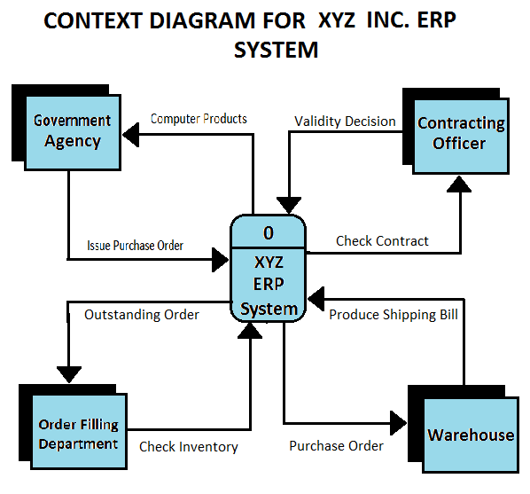

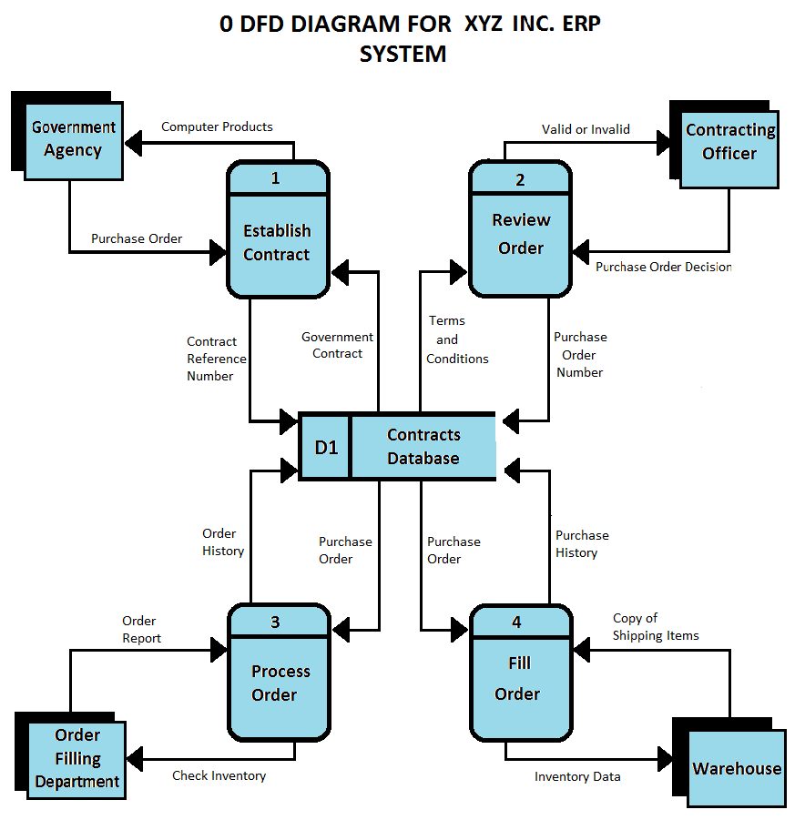

**Memo/Statement:**

July 20, 2014

From: Derrick Fox

To: Professor Webb

Subject: A memo on attached data flow diagrams

The following is an explanation of the processes depicted in the attached data flow diagrams. At the center of the diagram is XYZ Inc.’s Enterprise Resource Planning system. From it there are four major systemic processes. They begin with the establishment of the government contract between the client agency and the XYZ’s Contracting Officer. This allows the client to create a purchase order. The submission of the purchase order initiates the second process which is the reviewing of the purchase order against the agreed upon terms and conditions illustrated in the government contract. After this is complete the third process begins which is passing the purchase order to the Order Filling Department who goes on to check the inventory and process the order. Once XYZ has determined which items ordered are in the inventory and which are not, the information is then sent to the warehouse and an exception letter is generated and sent for any items order that are not in stock, if need be. This initiates the fourth and final step which is actually filling the order. This is a two-step process of pulling the items from the shelves and then physically shipping the equipment to the address listed in the contract.

**Class Diagram:**

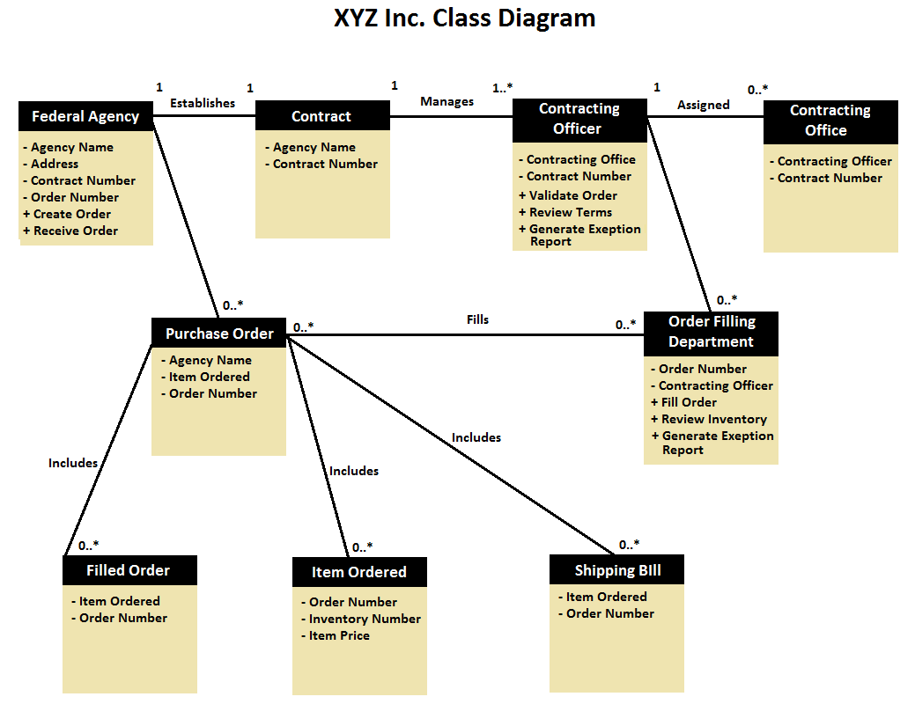

**Use Case Diagram:**

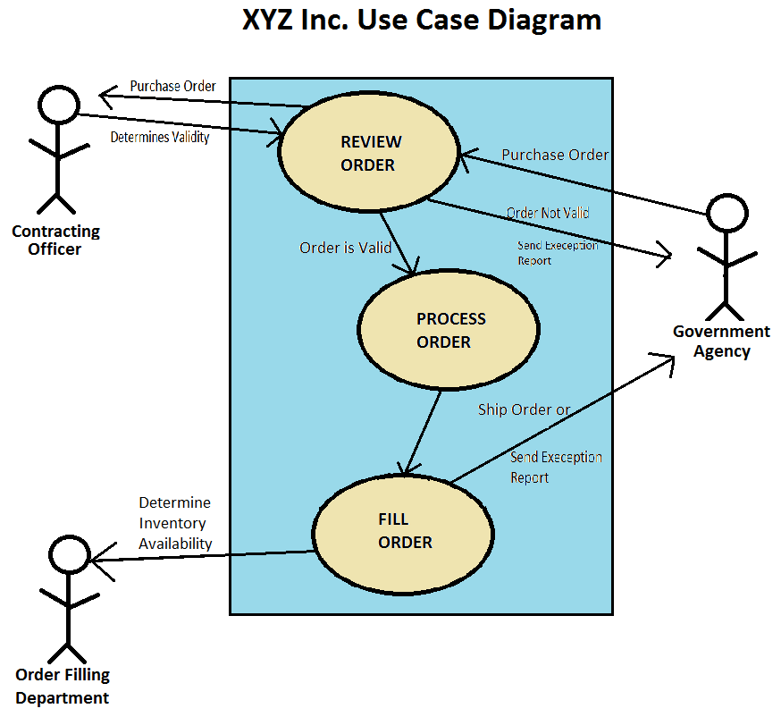

**Entity Relationship Diagram:**

